**Some clownfish have no personality, Australian study finds**

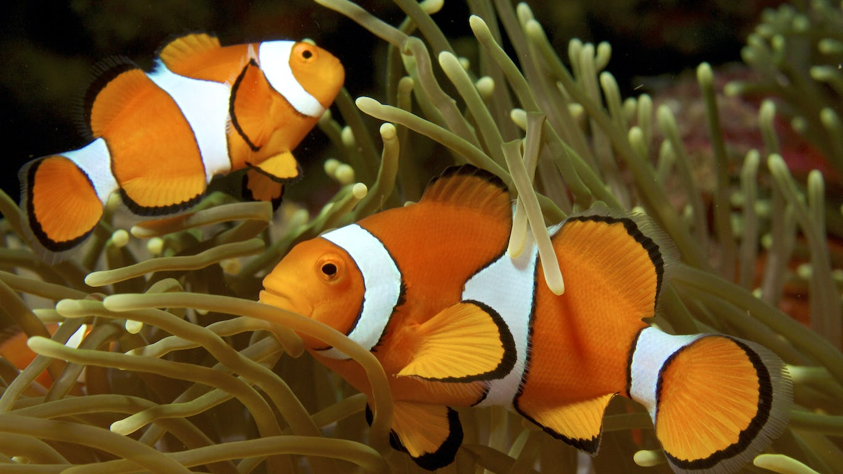Image 1: A new study says that — unlike the star of the film "Finding Nemo" — some clownfish have no personality. Photo from: Wikimedia Commons.

Word Count:593

Some species of clownfish have absolutely no personality, a study by Australian researchers has found.

Research by the University of Wollongong and Southern Cross University analyzed the behavior of two species of subtropical clownfish, or anemonefish. One is Amphiprion mccullochi. It lives only in a shallow lagoon on Lord Howe Island, off the coast of New South Wales, Australia. The other is Amphiprion latezonatus, which is commonly found along Australia's east coast.

The resulting paper, "Some Anemonefish Lack Personality," was published in December.

Scientists found that A.mccullochi displayed distinct, individual personalities. They did so mainly through varying degrees of bold or aggressive behavior. Meanwhile, Alatezonatus showed no discernible individual personality traits. These fish appeared to act as a group.

Tropical clownfish, such as Amphiprion ocellaris, is the species made popular by the Pixar movie "Finding Nemo" in 2003. These fish also showed distinct individual personalities. That makes A. latezonatus the bland one in the group.

Dr. Marion Wong, from the University of Wollongong, is the lead researcher. She said observing different personality traits in clownfish was no different from observing different personality traits in dogs. Humans accept the idea of different personalities in dogs because we spend so much time with them.

"We don't normally spend time and hang out with clownfish," she said. "But if we did do that and hang out with them like we hang out with our dogs, we would see that yes, they do have individual personalities."

Wong explained why the conclusion about A. latezonatus was drawn. It was not because they did not exhibit any interesting behaviors, but because all specimens observed during the study period behaved exactly the same.

"There wasn't much between-individual variation; individuals were quite consistent, but they were all on the same level of boldness and shyness," she said.

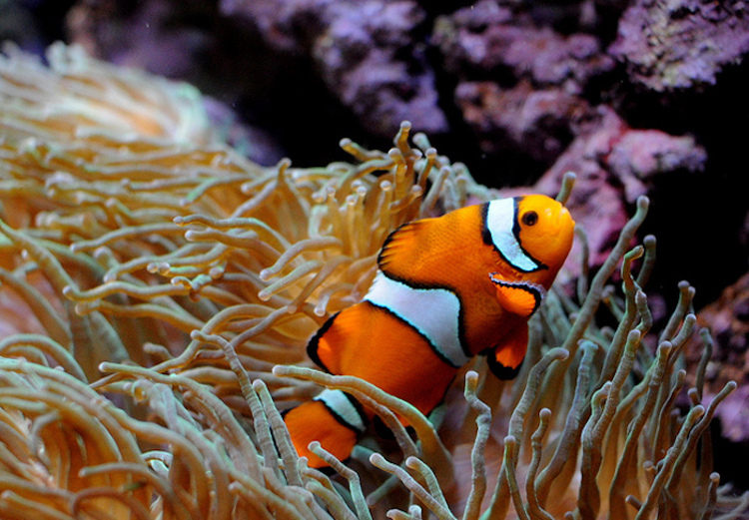Zoom-outImage 2: No clowning around with these fish. Photo from Flickr.

Scientists think that individuals have personalities if they behave differently in response to the same thing.

"One individual might have an over-inflated reaction to a stressful situation or a certain occurrence, whereas another one might have a really chilled-out reaction to it," Wong said. "So you tend to associate one with being anxious and one as being more relaxed."

About 60 individuals from both species were filmed in their natural environment using underwater cameras. Researchers recorded 15 minutes of footage at the same time each day. Then, they analyzed the footage to see how often individual fish showed three distinct types of behavior. These were boldness, aggression and sociability.

Each behavior was scored out of 10. Boldness was measured on how much time the fish spent out of contact with its anemone. Sociability was scored by the number of non-aggressive acts they performed with other clownfish. These included "meetings, soft touches of fins and submissive body shakes." Aggressiveness was measured by the number of aggressive acts toward other clownfish, including biting and chasing.

The study had a prediction. The A. latezonatus does not display individual personalities because it lives in a more dangerous, turbulent environment than the sheltered lagoon of A.mccullochi.

There is limited scientific research pointing to other personality-devoid fish. As a result, the way that A. latezonatus clownfish act as a group could actually be unique.

Or it could be that researchers find evidence of personality-less fish too dull to publish.

"We don't really know if that's just a feature of the fact that if researchers don't find a personality they don't publish the paper, or if it's quite unusual for a fish not to have an apparent personality," Wong said.